

**A Project Report**

**ON**

**“Vardhman Schools”**

**Academic Year**

**2021-2022**

**Developed By**

**Dhruvin Mehta**

**Yash Thummar**

**Under the Guidance of**

**Gaurav Badani**

**Submitted to**

**Shipra College, Saurashtra University**

**(Affiliated with Saurashtra University)**

**SHIPRA COLLEGE**

**OF**

**COMPUTER SCIENCE & TECHNOLOGY – RAJKOT**

**(Managed By : M. P. Education Trust)**

**15 - Sardar Nagar, B/h. Kings Plaza, Astron Chowk, Rajkot.**

**CERTIFICATE**

This is certify that _________________________________________ with seat no ___________ is a final year student of the Bachelor Of Computer Application (BCA) Saurashtra University, and is required to do a six month BCA project work in his/her fifth Semester. The experience gained by this project work, not only benefit the student to partially fulfill The requirement of the BCA of Saurashtra University, but also lay a foundation for his/her future career.

**H.O.D.**

Monali Dave

Shipra College of Com.Sci.

And Technology.

Rajkot

**Signature of principal**

Shipra College of Com.Sci.

And Technology.

Rajkot

**____________ ____________**

**Project Guide** **HOD**

Gaurav Sir

**  INDEX **

|  |  |  |
| --- | --- | --- |
| No. | Purticulars | Pg.no. |
| 1 | Acknowledgement | 03 |
|  |  |  |
| 2 | Preface | 04 |
|  |  |  |
| 3 | Introduction about Project | 05 |
|  |  |  |
| 4 | Requirement analysis | 07 |
|  |  |  |
| 5 | Gantt chart | 07 |
|  |  |  |
| 6 | E-R diagram | 08 |
|  |  |  |
| 7 | DFD diagram | 10 |
|  |  |  |
| 8 | Use case diagram | 15 |
|  |  |  |
| 9 | Data base table | 17 |
|  |  |  |
| 10 | Screen shots | 19 |
|  |  |  |
| 11 | Testing | 35 |
|  |  |  |
| 12 | Limitation | 37 |
|  |  |  |
| 13 | Future enhance | 37 |
|  |  |  |
| 14 | Bibliography | 38 |

** Acknowledgement **

Our Website, Which You Are Using, Is The Result Of Many People’s Dedication. It Is The Cumulative Efforts Of Many Minds Working Together Day And Night That Gave Us The Contentment Of Developing The Software.

Special Thanks To Mr. Gaurav Badani For His Great Support. We Express Our Gratitude To For Guidance And Who Kept The Things On Track And Also To All Other Faculty Members Who Helped Us Directly Or Indirectly.

Last But Not least Our Acknowledgement Goes To All The Well Wishers Of Our Project For Their Excellent Support In All Aspects.

** PREFACE **

There Is A Wide Different Between Theoretical And Practical Knowledge And To Understand That Different For The Use Of Knowledge. Project Report Is New And Interesting Experience For Us. We Say It Is Difficult From Particular Aspects; We Came To Know About The Theoretical Ideas Of The Matter And Its Dealing. Project Report Helps To Build Sin Our Life.

By Preparing This Report We Have Understood The Need Of Practical Training In The Education Field. It Is Easier To Work With Computerized System The Manual System. It Saves Time, Effort And Space And Also Increases The Efficiency By Creating Interest.

Our Project Is With Respect To “Vardhman Schools” The Project Report Contain The Information Regarding Information About School .The Concerned Persons Who Were Connected With Our Project Were Very Keen In Their Work And Provided Us With All The Useful Information. The Response From Them Was Very Positive And They Were Very Informal To Us.

This Project Is Part Of Our 5th Semester Of BCA Course Curriculum. We Here By Declare That It Is Our Own Work With Guidance Of The Faculty Members Of Our College.

** introduction **

Vardhman Schools From Site. This Is Our Project, Was Having Tried To Provide Online Registration , Admission , Login For Students . Which Student can apply for more other courses also. It Provides The Facility For Site Is Very Easy To Use & Gives Friendly Environment To Our Students.

The Student Can See The Details From Different Pages.

In Gallery Page You Can View Image Related To School.

A Student Can Login Into Site or they can Register If they are new student. Student can Apply for Admission via Form.

For The Admission We have Provided a very user friendly form for the student to fill up.

We are Providing the Notice Page for Students to get Updates about School.

We also Provides the Faculty Page for Students to know about there Faculty.

We Also Change Admin Side Stay In Client Side.

From Admin Side You Can Add New Faculty Details As Well As You Can Also Delete, Insert Any Items.

We also Provides the Information Like Timing, Campus Facility , Feedback and many more.

** project profile **

**Project title :** Vardhman Schools

**Platform :** Windows 7, 8, 10

**Front End :** JavaScript, Dhtml , Html , Php

**Back End :** MySql

**Documentation Tool :** Microsoft Word 2016

**Operating System :** Windows 7,windows 8/8.1,Windows 10

**Web Server :** XAMPP

**Web Browser :** Internet Exp. 8,Mozila Firefox, Google chrome

**Editor :** Macromedia Dreamweaver 8

**Guided By :** Gaurav Badani

**Submitted To :**  Shipra College - Rajkot

**Project Duration :** 3 Months.

**Developed By** **:** Dhruvin Mehta

Yash Thummar

** requirement analysis  **

Requirement Is Study Of The Current Business To Find How It Can Be Work And Where Should It Be Improved.

This Is The Study Of System To Find How And Where System Can Be Improved Or Make Easily Can Do Work.

Requirement Should Be Always Include In New System And Improve The System. This May Be Processing Of The Data Producing Information, Controlling A Business Activity, Etc.

** e-r diagram **

E-R Diagram Are One Of The Better Ways To Communicate Different Of A Components Of A System. They Are Also Too Easy To Understand By Everyone. An E-R Diagram Is Graphical Method Of Representing Entity Classes, Attributes And Relationship. An E-R Diagram Uses Six Basic Symbols.

Rectangle:-

A Rectangle To Denote An Entity Set.

Diamond:-

A Diamond To Demote A Relationship Between

Two Entity.

Oval:-

An Oval To Denote Attribute.

Line:-

A Line Which Link Attributes To An Entity Or

Entity Set And Entity Sets To Relationship.

Single:-

A ‘1’ To Denotes Single Occurrence.

Multiple:-

A ‘m’ To Denote Multiple Occurrence.

* **E-R Diagram:-**

has

Feed back

shipping

has

Admin_Login

Shipping cart

Vardhman

School

Register

payment

login

Faculty

has

has

** data flow diagram **

Contact

The Dataflow Diagram Are Graphical Representation Of The Outline Of The study System.

The Data Flow Diagram Covers all The Processes And The Data Storage Area Which Tacks During Any Transaction In The System.

* Symbols:-

Process: - Hear Floe Of the Data Is Transformed E.G.Issue,Deposite Etc.

Eaternal Entity: - A Source Or Destination Of Data Which Is External Of The System.E.G. Student, Teacher.

Data Flow: - It Is A Packet Of Data It Be In The Form Of Document, Letter

Data Store: - Any Store Data But With No Reference To The String.

* **CONTEXT LEVEL DIAGRAM.**

ADMIN

CLIENT

Register

* **CLIENT:- 0 Level Diagram**

1

Admission

All category

2

FEEDBACK

CLIENT

T1 FEEDBACK

**CLIENT** :- **1 Level Diagram**

3

CONTACT US

1.1

Add Faculty

T2 SHIPPING

1.5

Submit

1.6

Home

1.4

register

2

Designation

1

Name

1.3

Qualification

Experience

T3T log-ragit4 T4 log-ragi

T4 log-ragi

T3 Apply

**ADMIN** :- **0 Level Diagram**

2

Feedback

Admin

6

Contact

5

Faculty

4

Admission

3

Registration

**ADMIN** :- **1 Level**

7

feedback

1

category

4

Admission

3

Faculty

admin

2.2

listsubcategory

6

payment

8

Contact

8.2

delete

8.1

view

7.2

delete

7.1

view

6.2

delete

6.1

view

5.2

delete

5.1

view

5

Registration

4.4

delete

4.3

edit

4.2

Add Product

4.1

Add Product

3.4

delete

3.3

edit

3.2

*List* Faculty

3.1

Add Faculty

2.3

edit

2.1

Addsubcategory

2.4

delete

1.3

edit

1.2

list category

2

Contact

1.4

delete

1.1

Add category

** USE CASE DIAGRAM **

**Client:-**

* **Admin:-**

 Database Table 

Feedback Table:-

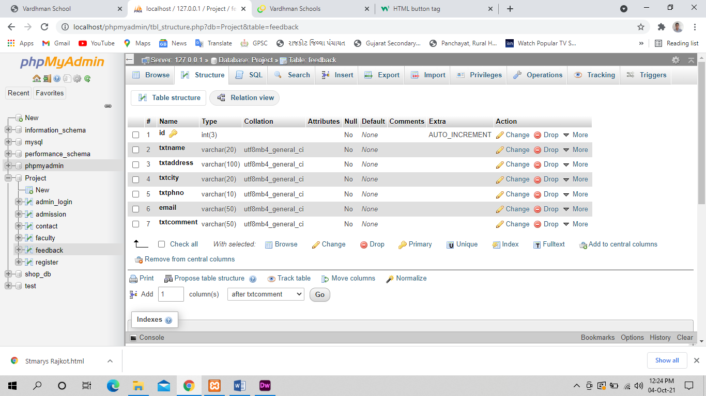

Faculty:-

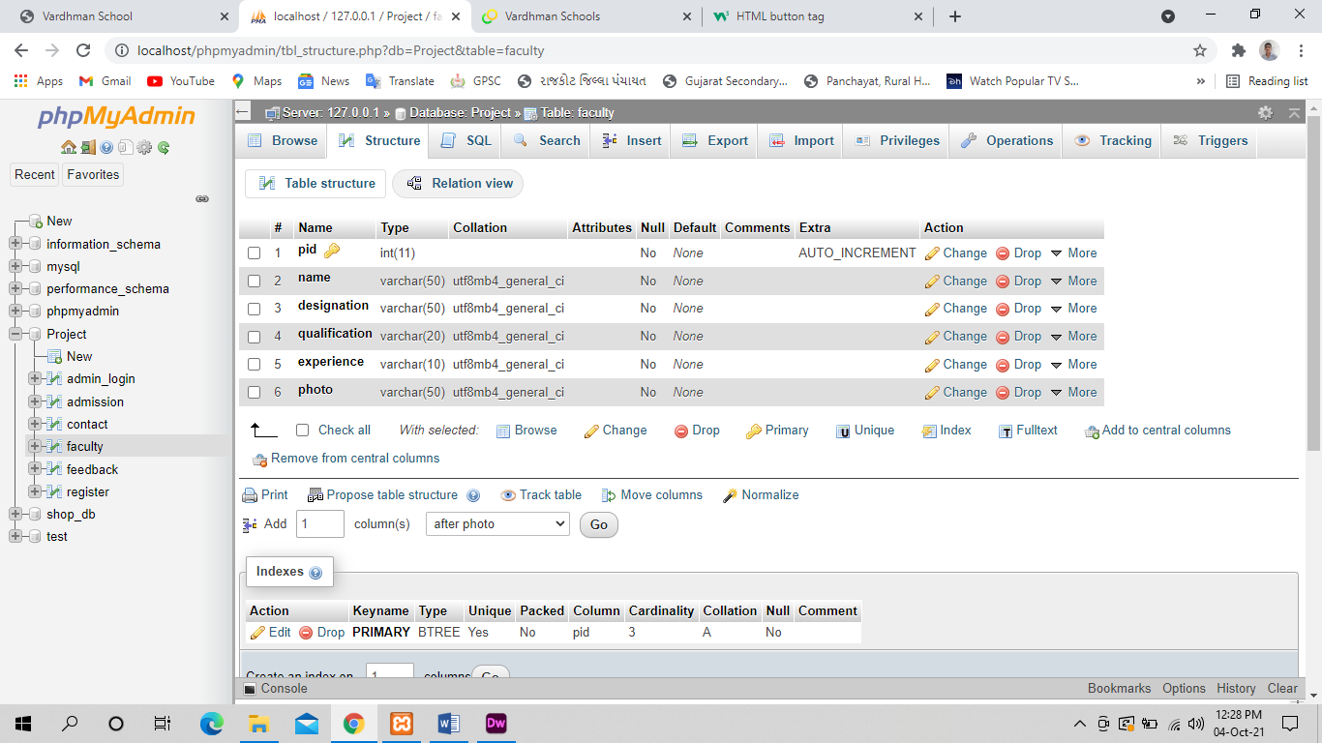

Admission :-

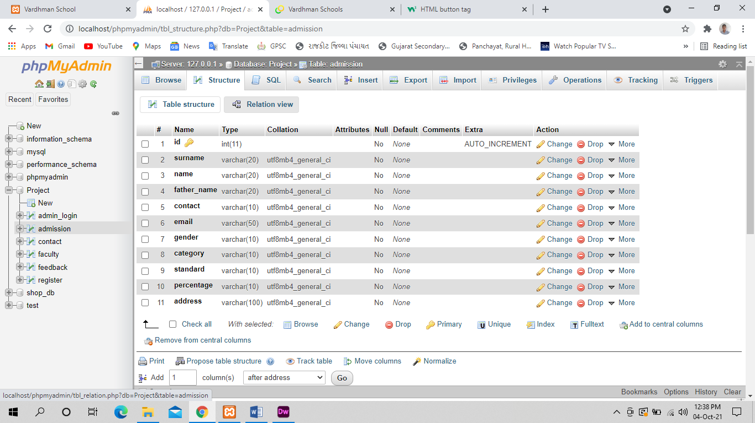

Registration :-

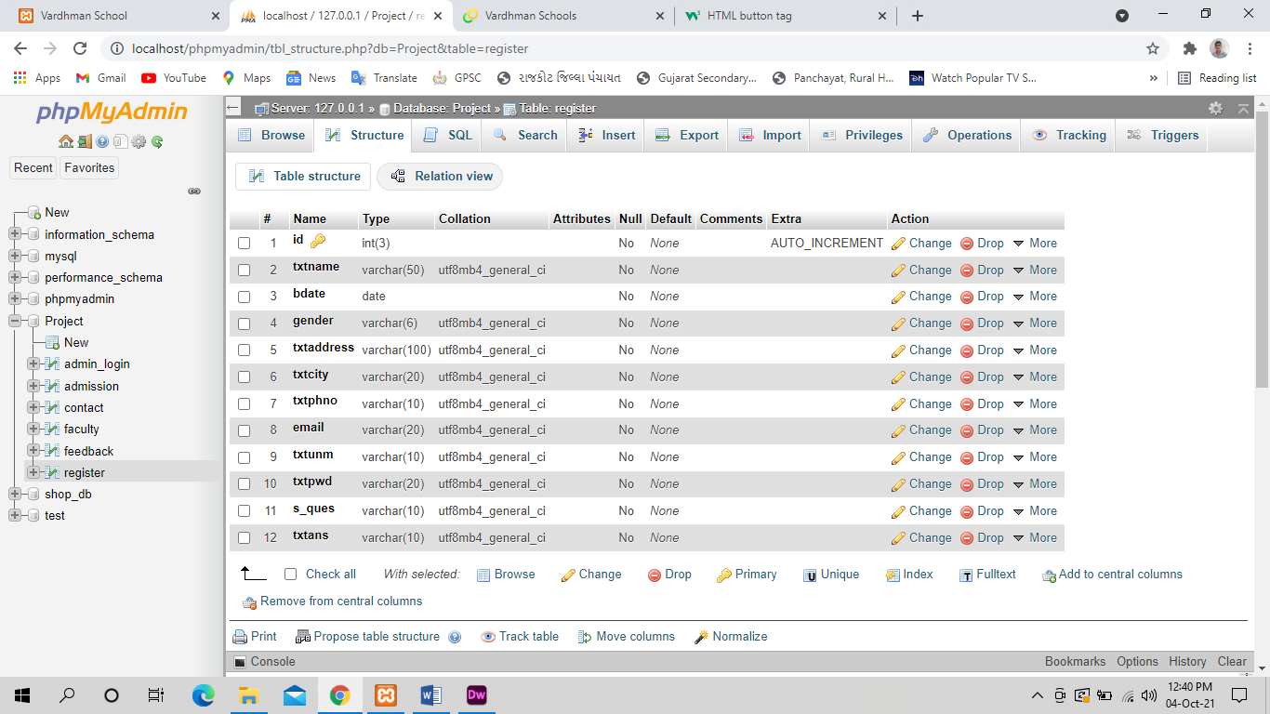

Contact Us:-

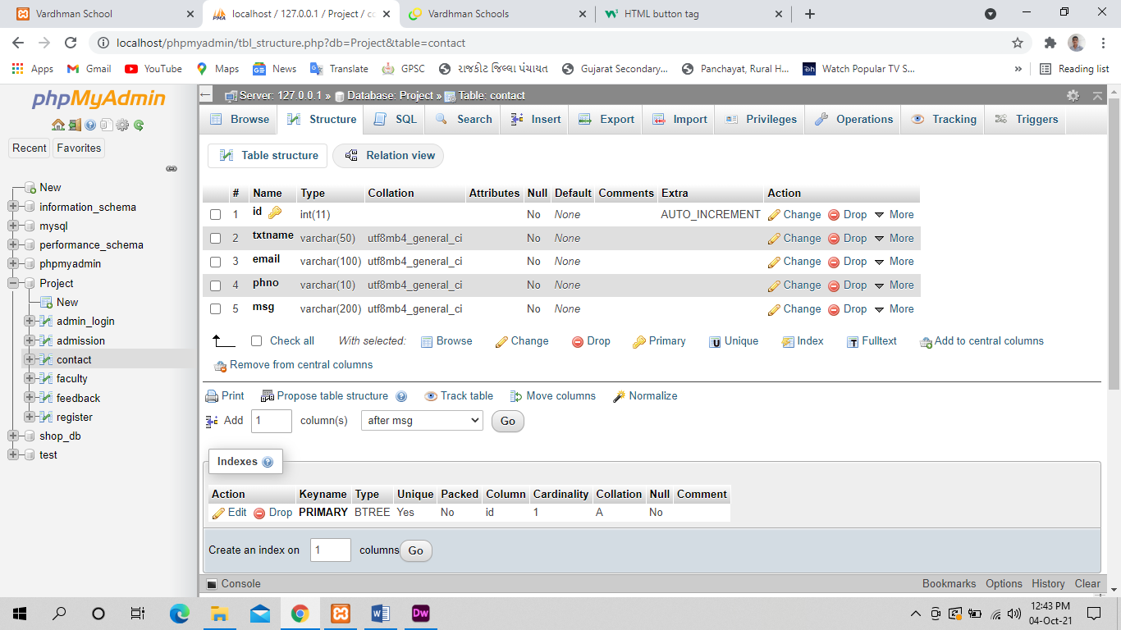

**      screen shot of website **

**          index page **

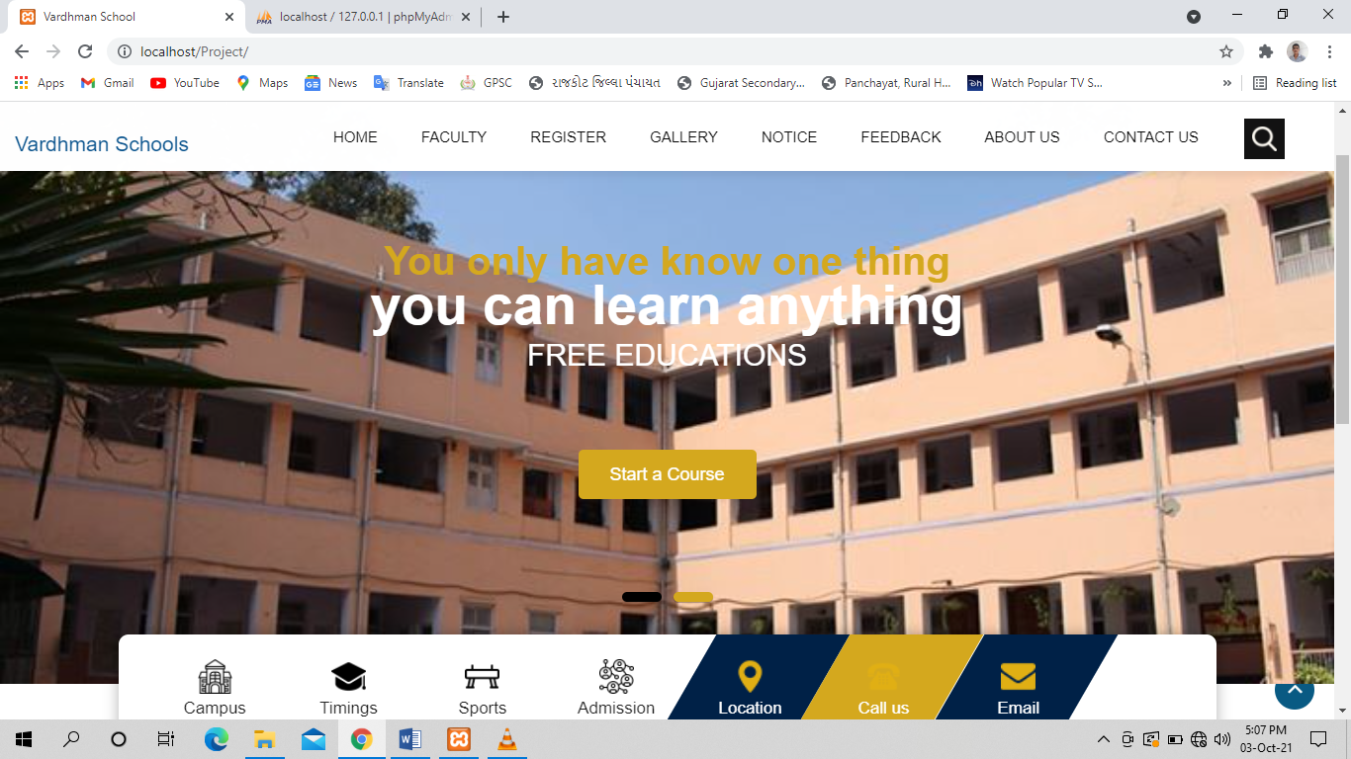

**INDEX**

For Student login we provide login form facility for Student.

** home page **

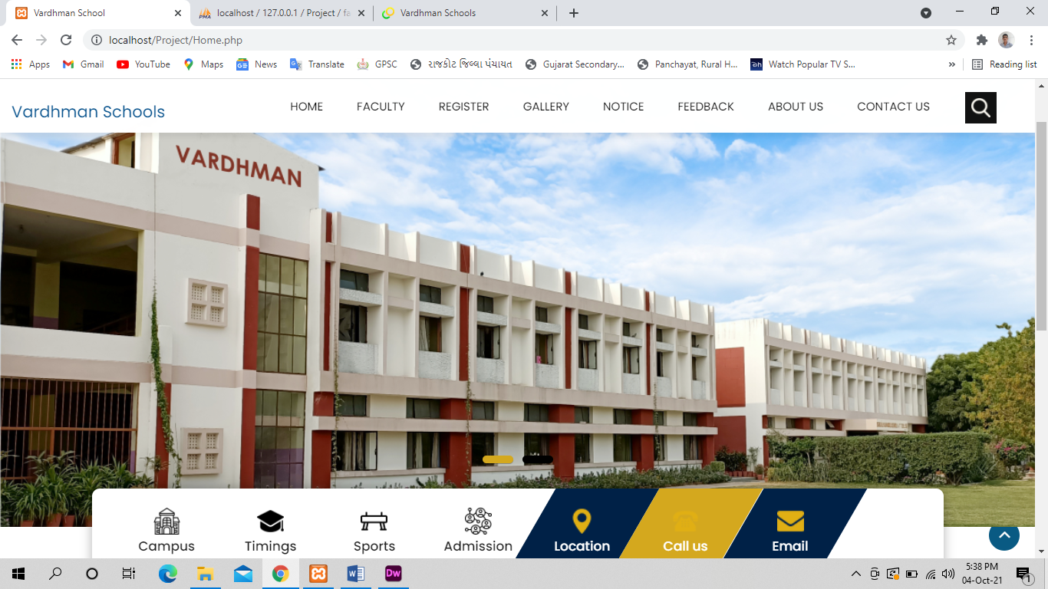

**HOME**

we provide best facitily for any user.if any user get entry in website so that can login ..and see the all information of our web site and our all brand.and if you like any product you can purchase. But without login you can’t purchase.

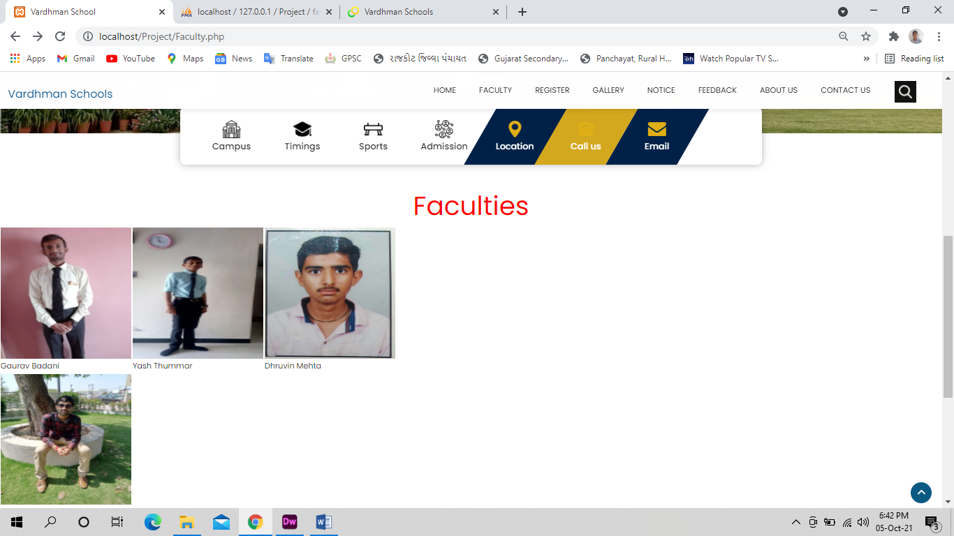** Faculty **

**Faculty**

We want to give a best accommodation to any Student.If any Student want have doubts then they can ask to any of the teachers. Student time savings and Faculty also eager to help the Students.

** School Campus **

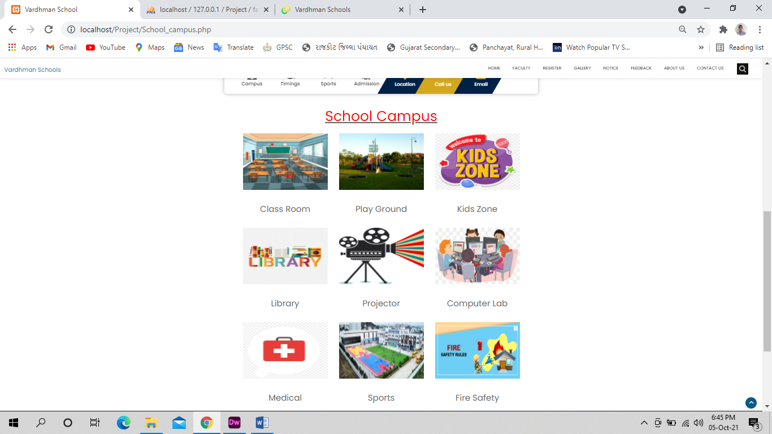

**School Campus**

If any Student want to live freely then we provides a very well Campus.

Students can watch movies, stay in library, can play in Play Ground.

We also take care of our Students that medical, fire safety and many more facilities given here.

**  **

** **

**   Timing **

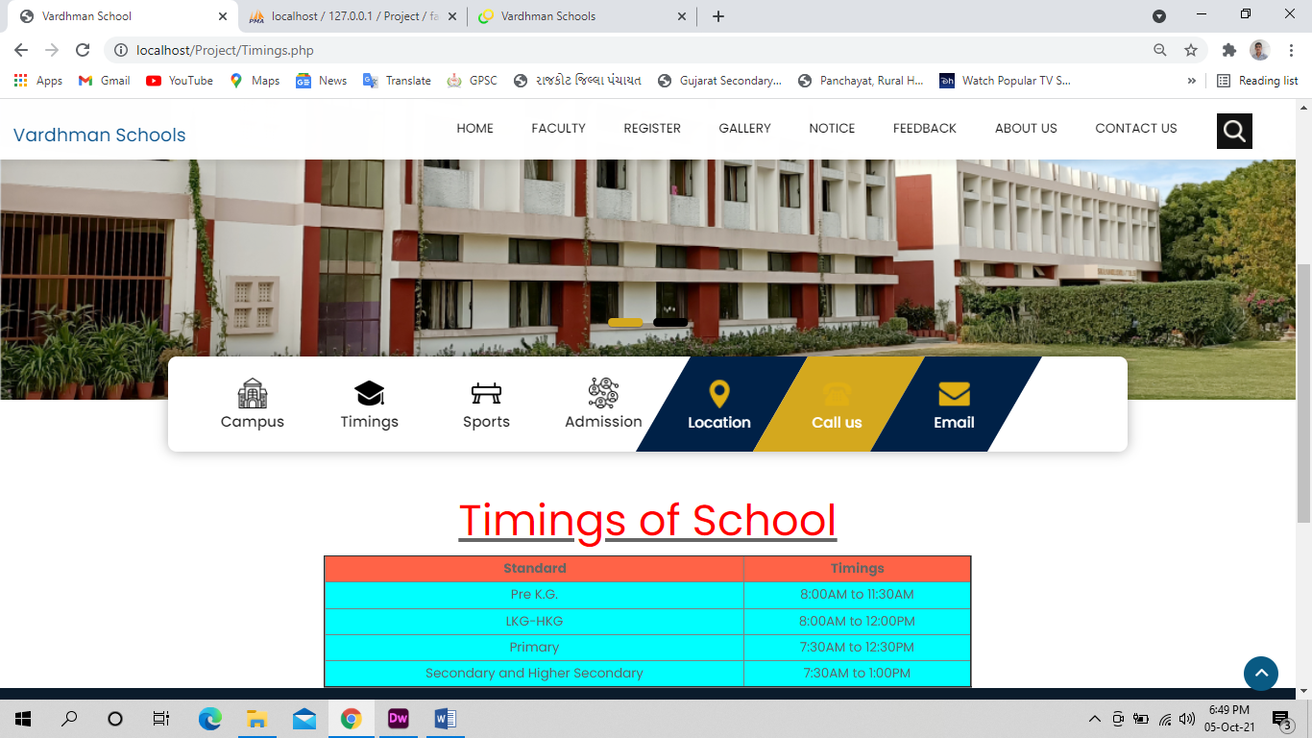

**            Timings**

We also Provides the Time Table as per Section wise so he Student & Parents can know about that.

** notice board **

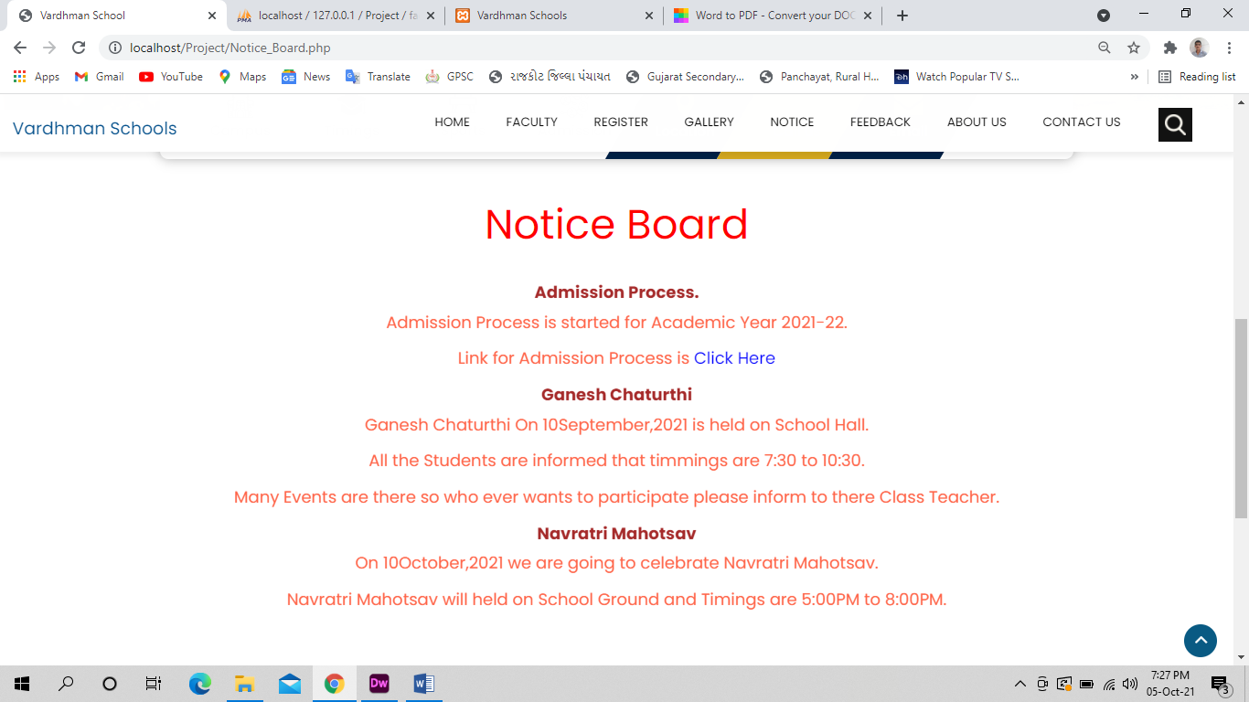

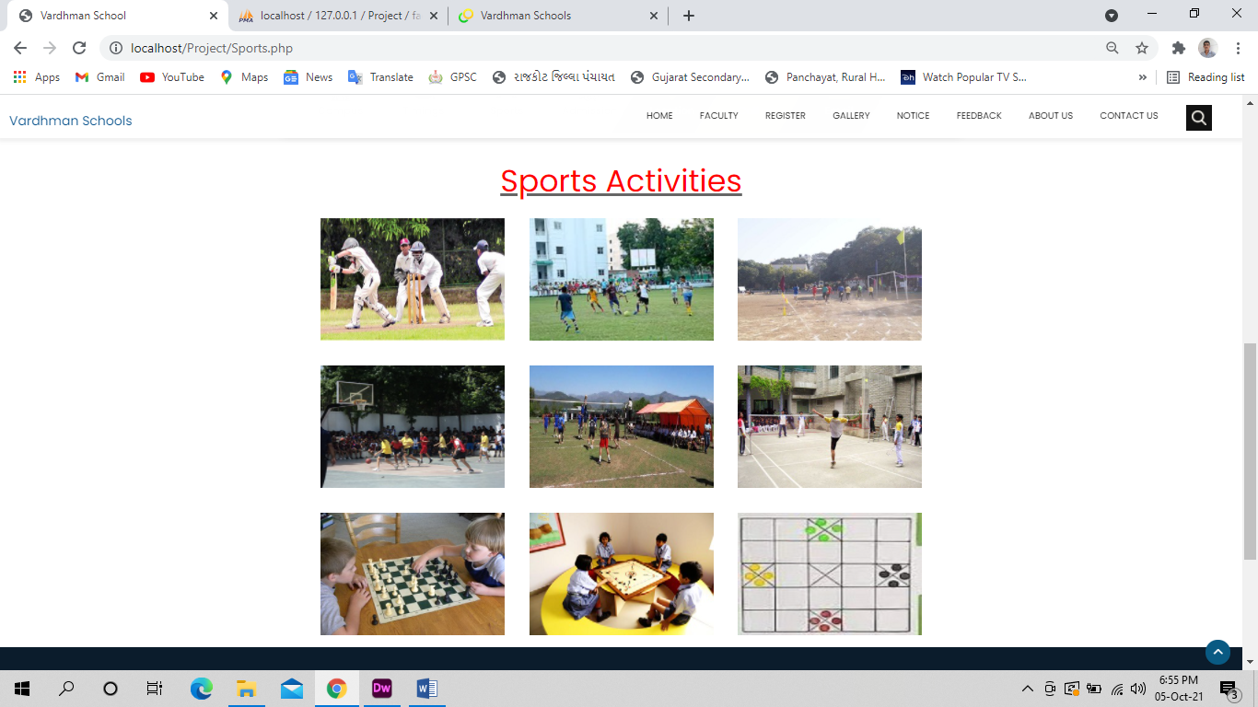** Sports **

**Sports**

We Provides a Great Sports Activities like Cricket, Football, Basket Ball, Badminton, Chess, Volley Ball, Atheletics and Many more.

** Admission Form **

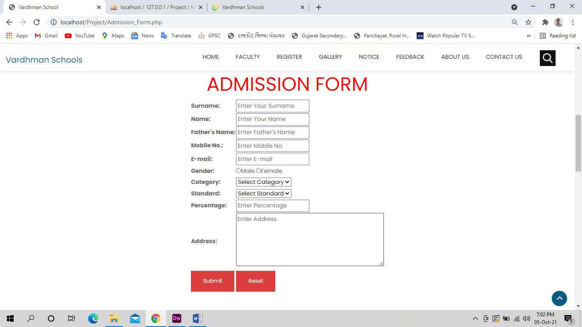

**Admission Form**

Admission Form Provided for a new Student who ever want to Apply For Admission and can refer for further process.

** registration form **

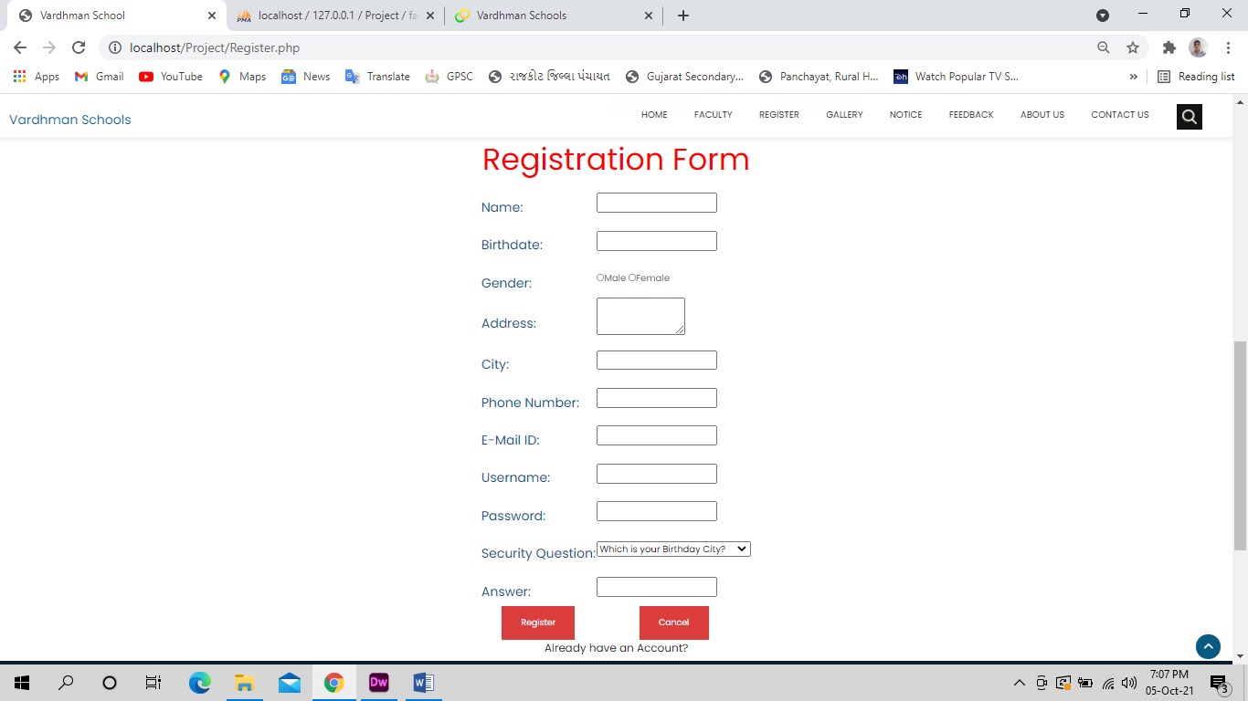

Registration

Who are the Students Of Vardhman can Register their Profile in our Website.

After Register only you can Login the Website.

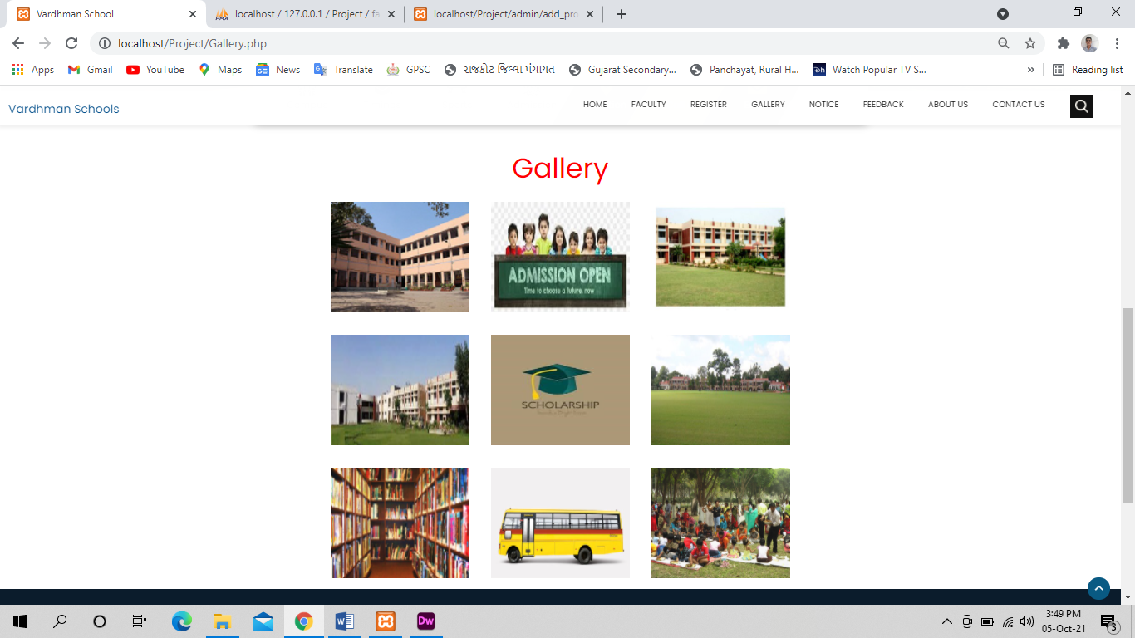** GALLERY **

Gallery

Gallery Provides the Pictures of our websites.

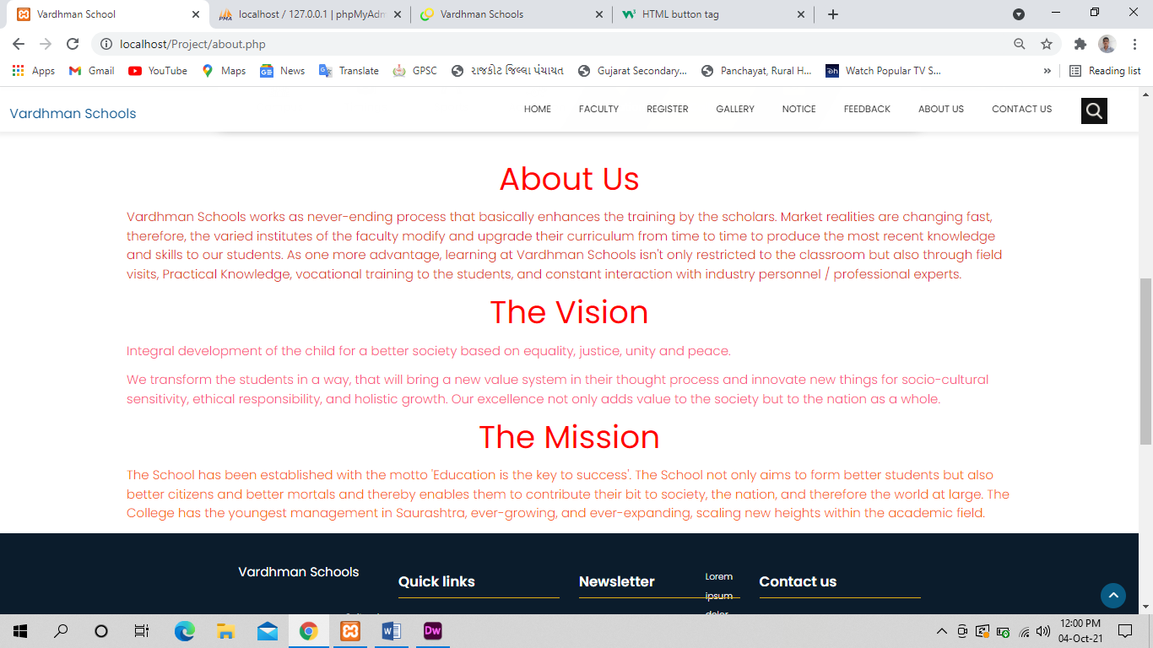** ABOUT US **

**ABOUT US**

Student get any information about our website so they see all information about us.

**  CONTACTS US **

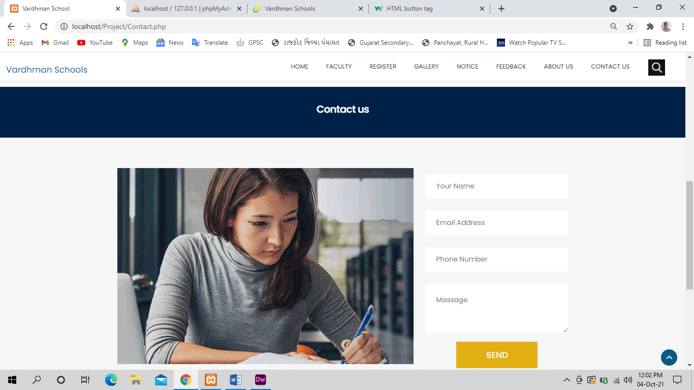

**CONTACT**

Student get any information about our contact so they see all information contact us.

** FEEDBACK FORM **

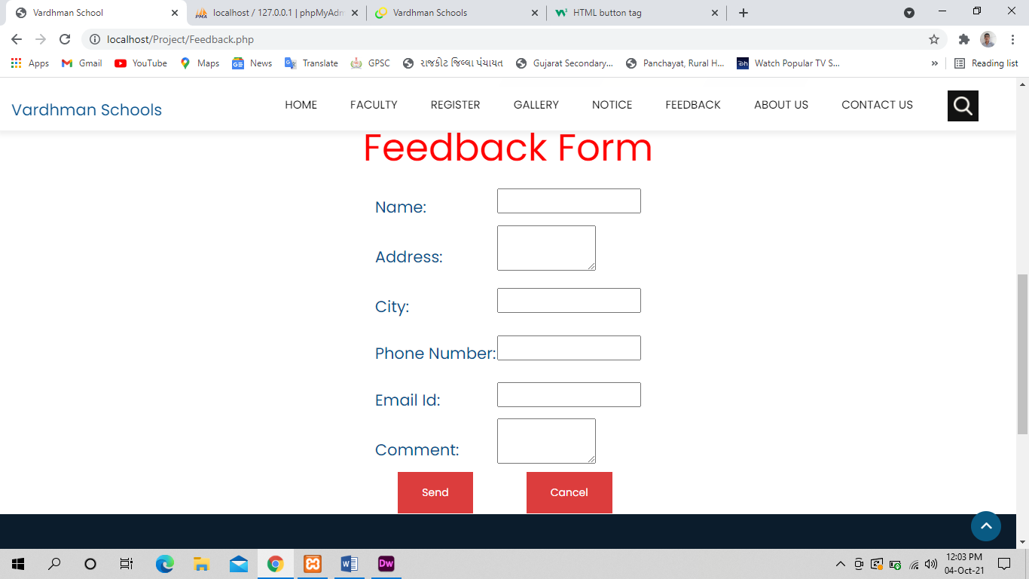

**FEEDBACK**

After visiting Student want to give any comment or any message so they can fill the feedback form.

** ADMIN SIDE SCREEN SHOT **

**  LOGIN PAGE **

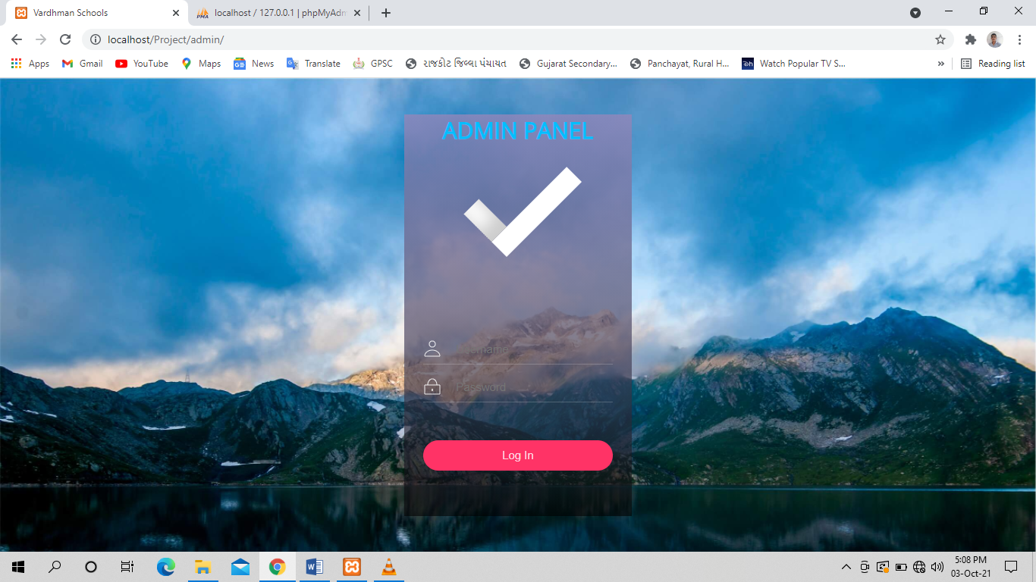

**LOGIN**

Admin can be open admin site. through username and password.

**  Faculty **

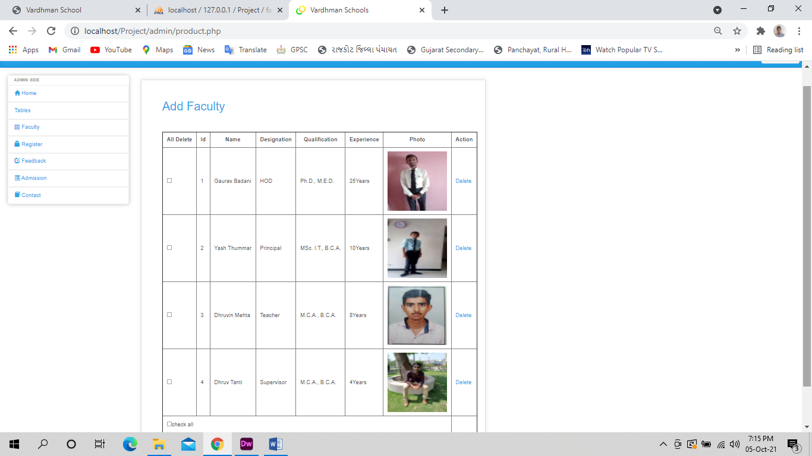

**Faculty**

Admin want to any changes so can be add Faculty and update , delete. And admin want show list of Faculty so possible.

** Add faculty **

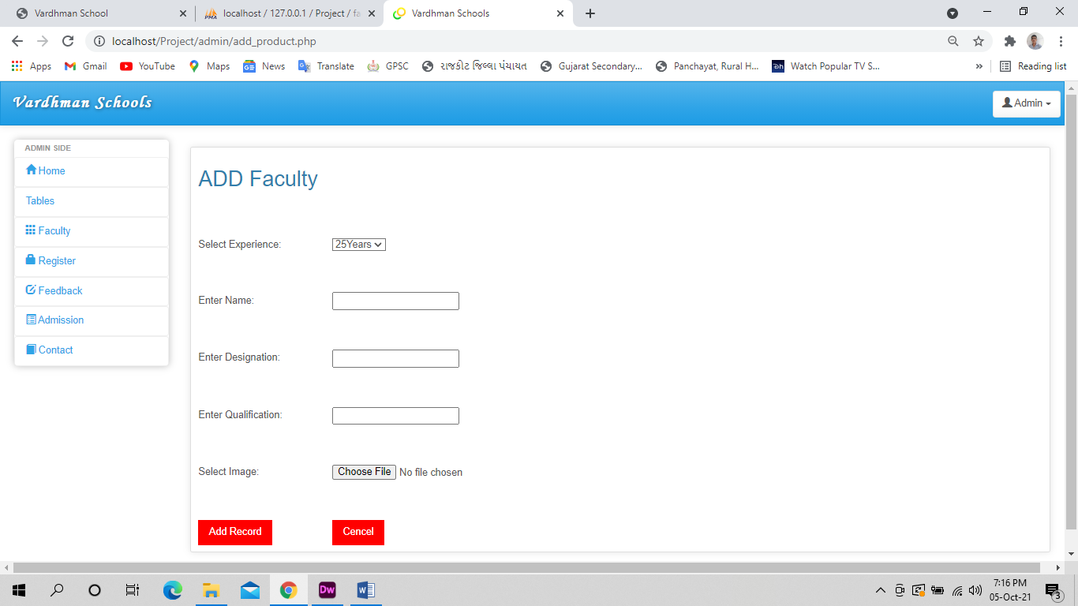

**Add Faculty**

Admin want to add Faculty then he/she can Add faculty.

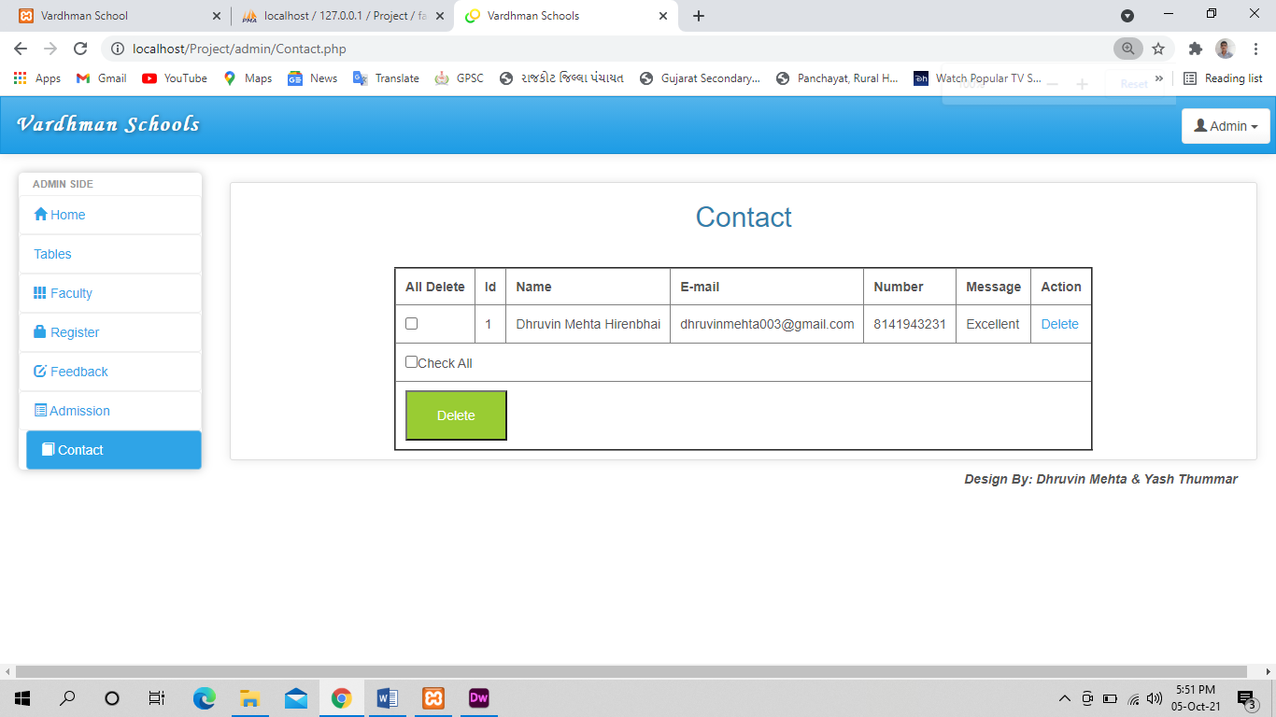** Contact **

**Contact Us**

Admin can delete data of Contact Us.

** Admission **

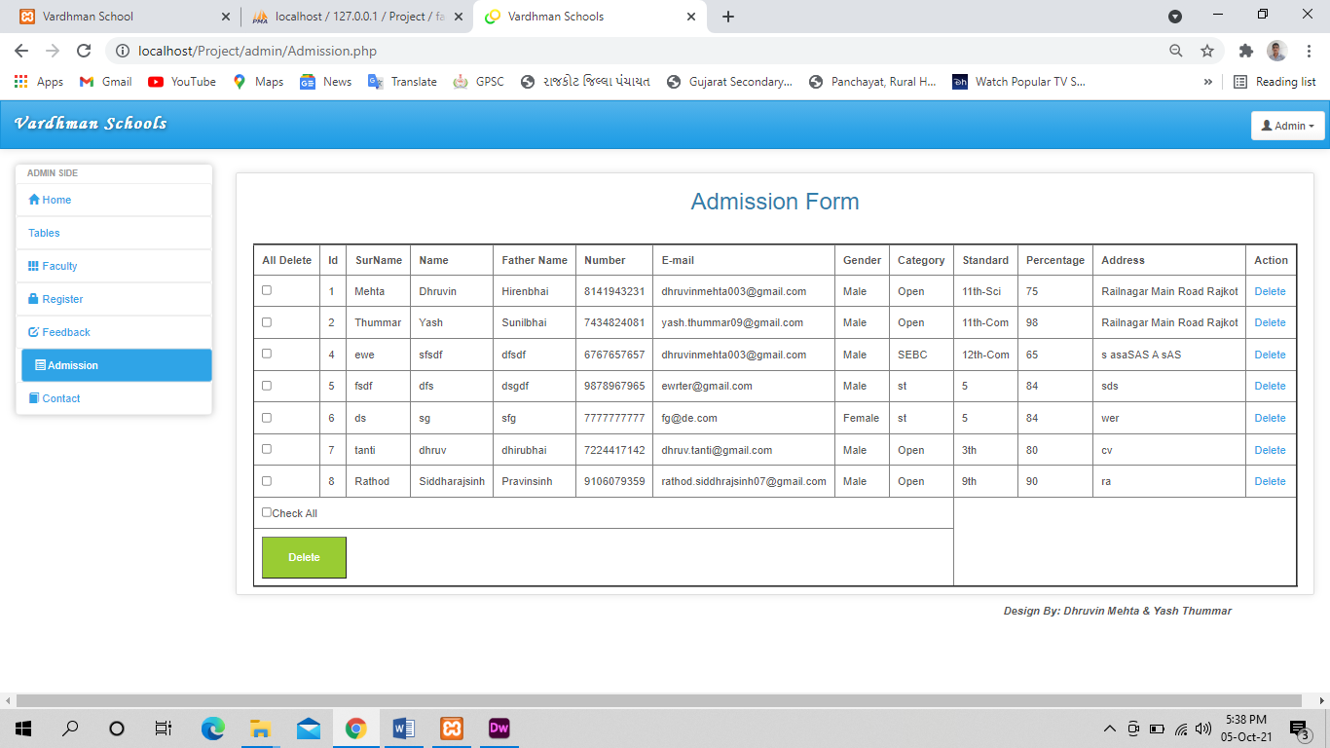

**  Admission**

Admin can delete data of Admission.

** FEEDBACK **

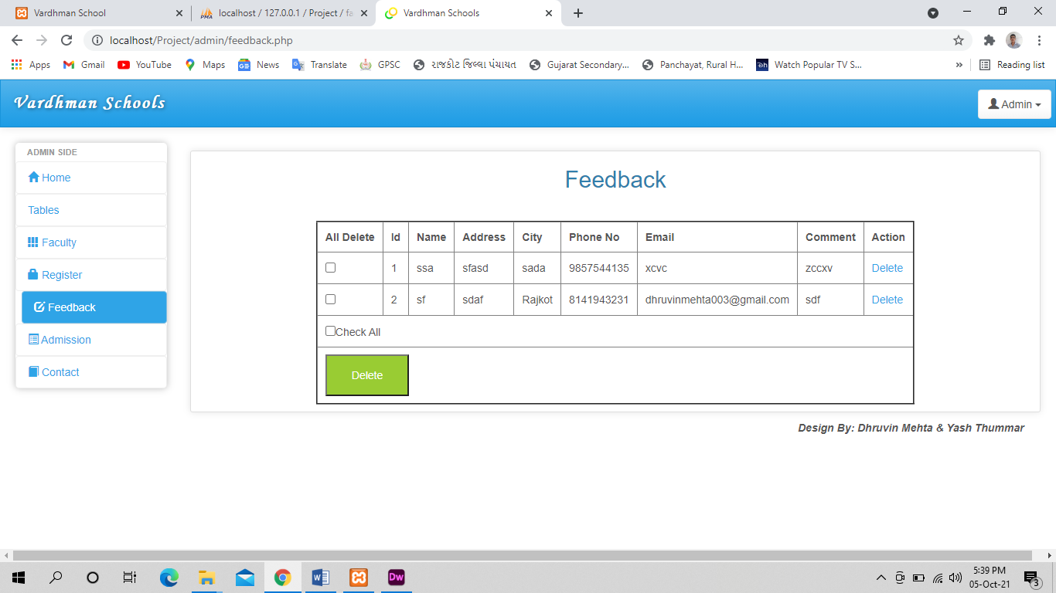

**FEEDBACK**

Admin can delete data of feedback.

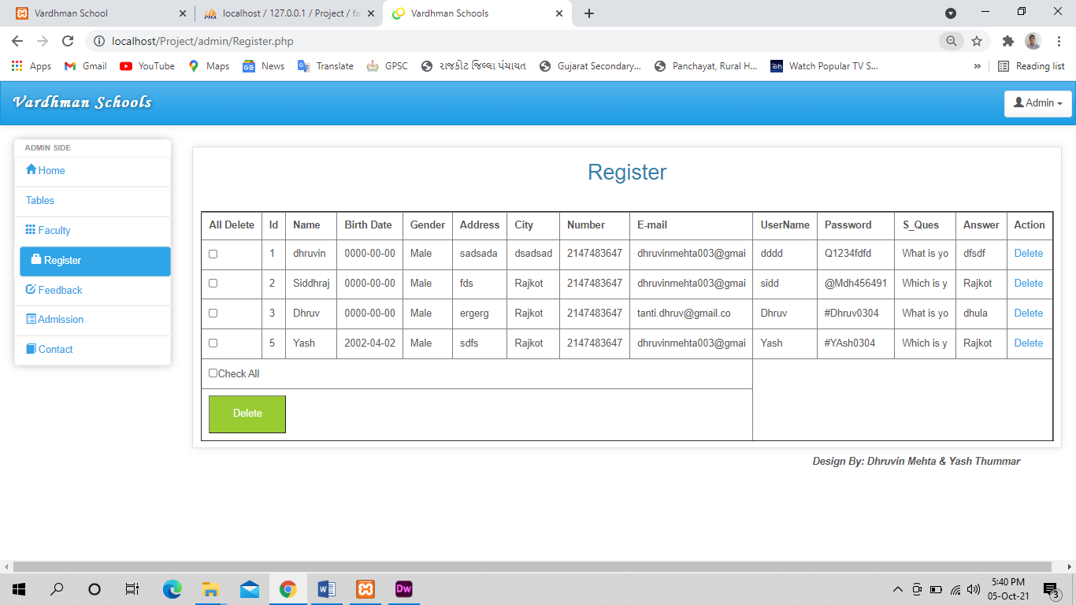** REGISTRATION **

**REGISTRATION**

Admin can delete data of registration.

** TESTING **

**REGISTRATION.**

|  |  |
| --- | --- |
| **Purpose** | To Register Student |
| **Input** | User’s click on “SUBMIT” button. |
| **Processing** | Store all the validated information in to the database. |
| **Output** | Message indicates that you are registered properly. |

**LOGIN.**

|  |  |
| --- | --- |
| **Purpose** | To login authenticated admin, and Student. |
| **Input** | Valid username and password |
| **Processing** | First do the client side validation and then authenticate the user after verifying from database. |
| **Output** | Student, instructor or admin redirect to mail page  . |

**OUTBOX**

|  |  |
| --- | --- |
| **Purpose** | Interface to the user to check his/her email |
| **Input** | Input Message |
| **Processing** | Save data in our database |
| **Output** | Message indicates that you are registered properly. |

**SEND MAIL**

|  |  |
| --- | --- |
| **Purpose** | Interface to the user to check his/her email |
| **Input** | Input sender user detail. |
| **Processing** | Check the user and then store database and send mail to sender user |
| **Output** | Message indicates that you are registered properly. |

**  limitation **

* We cannot give you facility of not direct Login without Register.
* The site does not have backup or restore facility of database.
* We are offering students for check day to day work.
* We are only use this site for Informative Purpose only.

** future enhance **

we may appear one way in the physical world, and have a whole range of digital appearances in the augmented reality and virtual environment worlds. These new worlds will need to be designed, and education will play a similar role to that in the real world. Form and function will be separated, at least as far as IT is concerned From designers to editors, the education is always looking for talented Students. Find out more about the career trends of the Educational world.

Education is a Key to Success.

A career in the Education Field can offer you many unique, exciting opportunities. No matter what your area of interest entails, there are numerous opportunities in the ever-changing industry of fashion.

**Education:-**

The Education is a fast-paced industry that is constantly changing. No matter the area of education you are pursuing in your studies, you must be aware of the competition that you may face. After Education jobs are growing very fast. In fact, the Bureau of Labour Statistics (BLS) reports that the job growth rate is expected to rise only 95 percent from 2008 to 2018. But do not worry, the education world is always looking for talented new people for new education trends.

.

** bibilography **

**Reference Book :-**

Beginning PHP6, APACHE, MYSQL WEB DEVLOPMENT

**Websites :-**

[StmarysRajkot.html](Stmarys%20Rajkot.html)

[www.w3school.com](http://www.w3school.com)

**THANK YOU**